**MCT 311- Design of Machine Elements and CAD/CAM**

________________________________________



**Complex Engineering Activity**

# SUBMITTED TO:

# Mam Amina Yousaf

**SUBMITTED BY:**

HASEEB-UL-HASSAN (2022-MC-58)

___________________________________

**Mechatronics and Control Engineering Department**

University of Engineering and Technology, Lahore

1. Abstract:

The design and development of an efficient gear reducer box tailored for integration with a brushless DC (BLDC) motor to drive a bicycle wheel is presented. The primary objective of this study is to enhance torque transmission and optimize the motor's performance to meet the power and speed requirements of an electric bicycle. The gear reducer box features a compact and lightweight design to maintain the overall efficiency and portability of the bicycle while ensuring robust and durable operation under variable load conditions. Key design considerations include gear ratio optimization, material selection, thermal management, and noise reduction. This design aims to provide a seamless and energy-efficient drivetrain solution, thereby contributing to the growing demand for sustainable and cost-effective electric mobility solutions. Testing and validation of the design will involve simulation and real-world performance evaluations to ensure reliability and compatibility with standard bicycle systems. (AI Generated)

1. Introduction
2. Project description (Introduction of chosen design and reason of selection)

As we are living in modern era of science sustainability is one of the most focused things discussed and implemented so thinking about the time management and human interaction, I decided why not we engage motor with bicycle to increase the awareness and importance of mobility and environmental sustainability, I have chosen a very specific application to incorporate the Design of machine elements course with real world problems

1. Details of research work done for finalizing project:

Today in the market there are many bicycles available with a BLDC motor incorporated but there is huge price of these products and I thought that if I could design a cheap system for developing

1. Important Features:

The entire system I want to design is simple and robust and it will have following feature:

* Long Life (9999 h)
* Require less Space
* Approx. less then 18% power loss
* Simplest design

1. Figure:

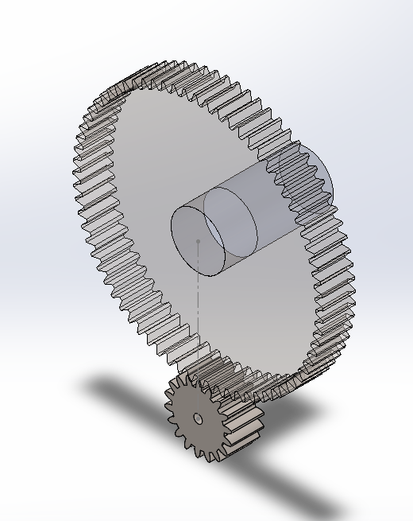

1. Methodology:

* Assumptions (if any):

I assumed that Av factor is 6 and open gearing for Cma

* Updated/ Finalized design (if any changes made in initial design)

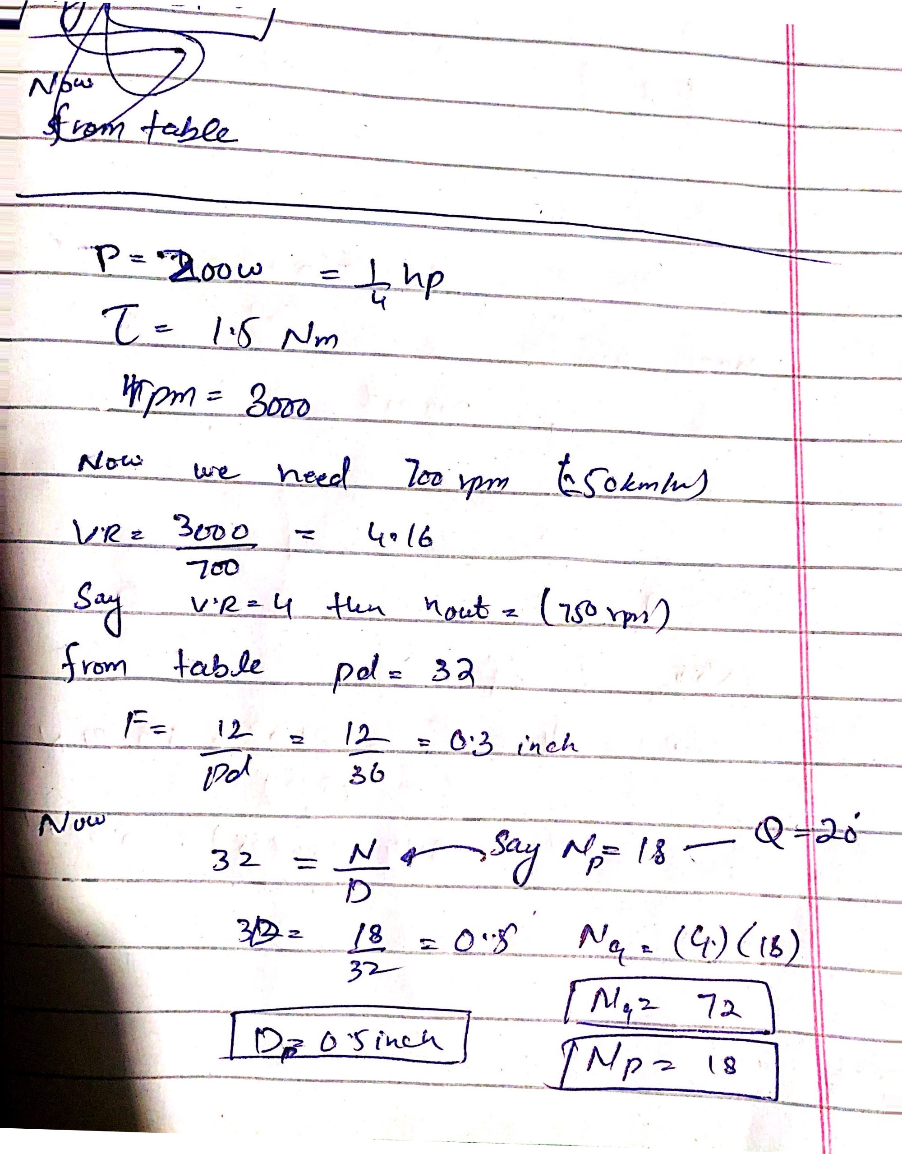

* 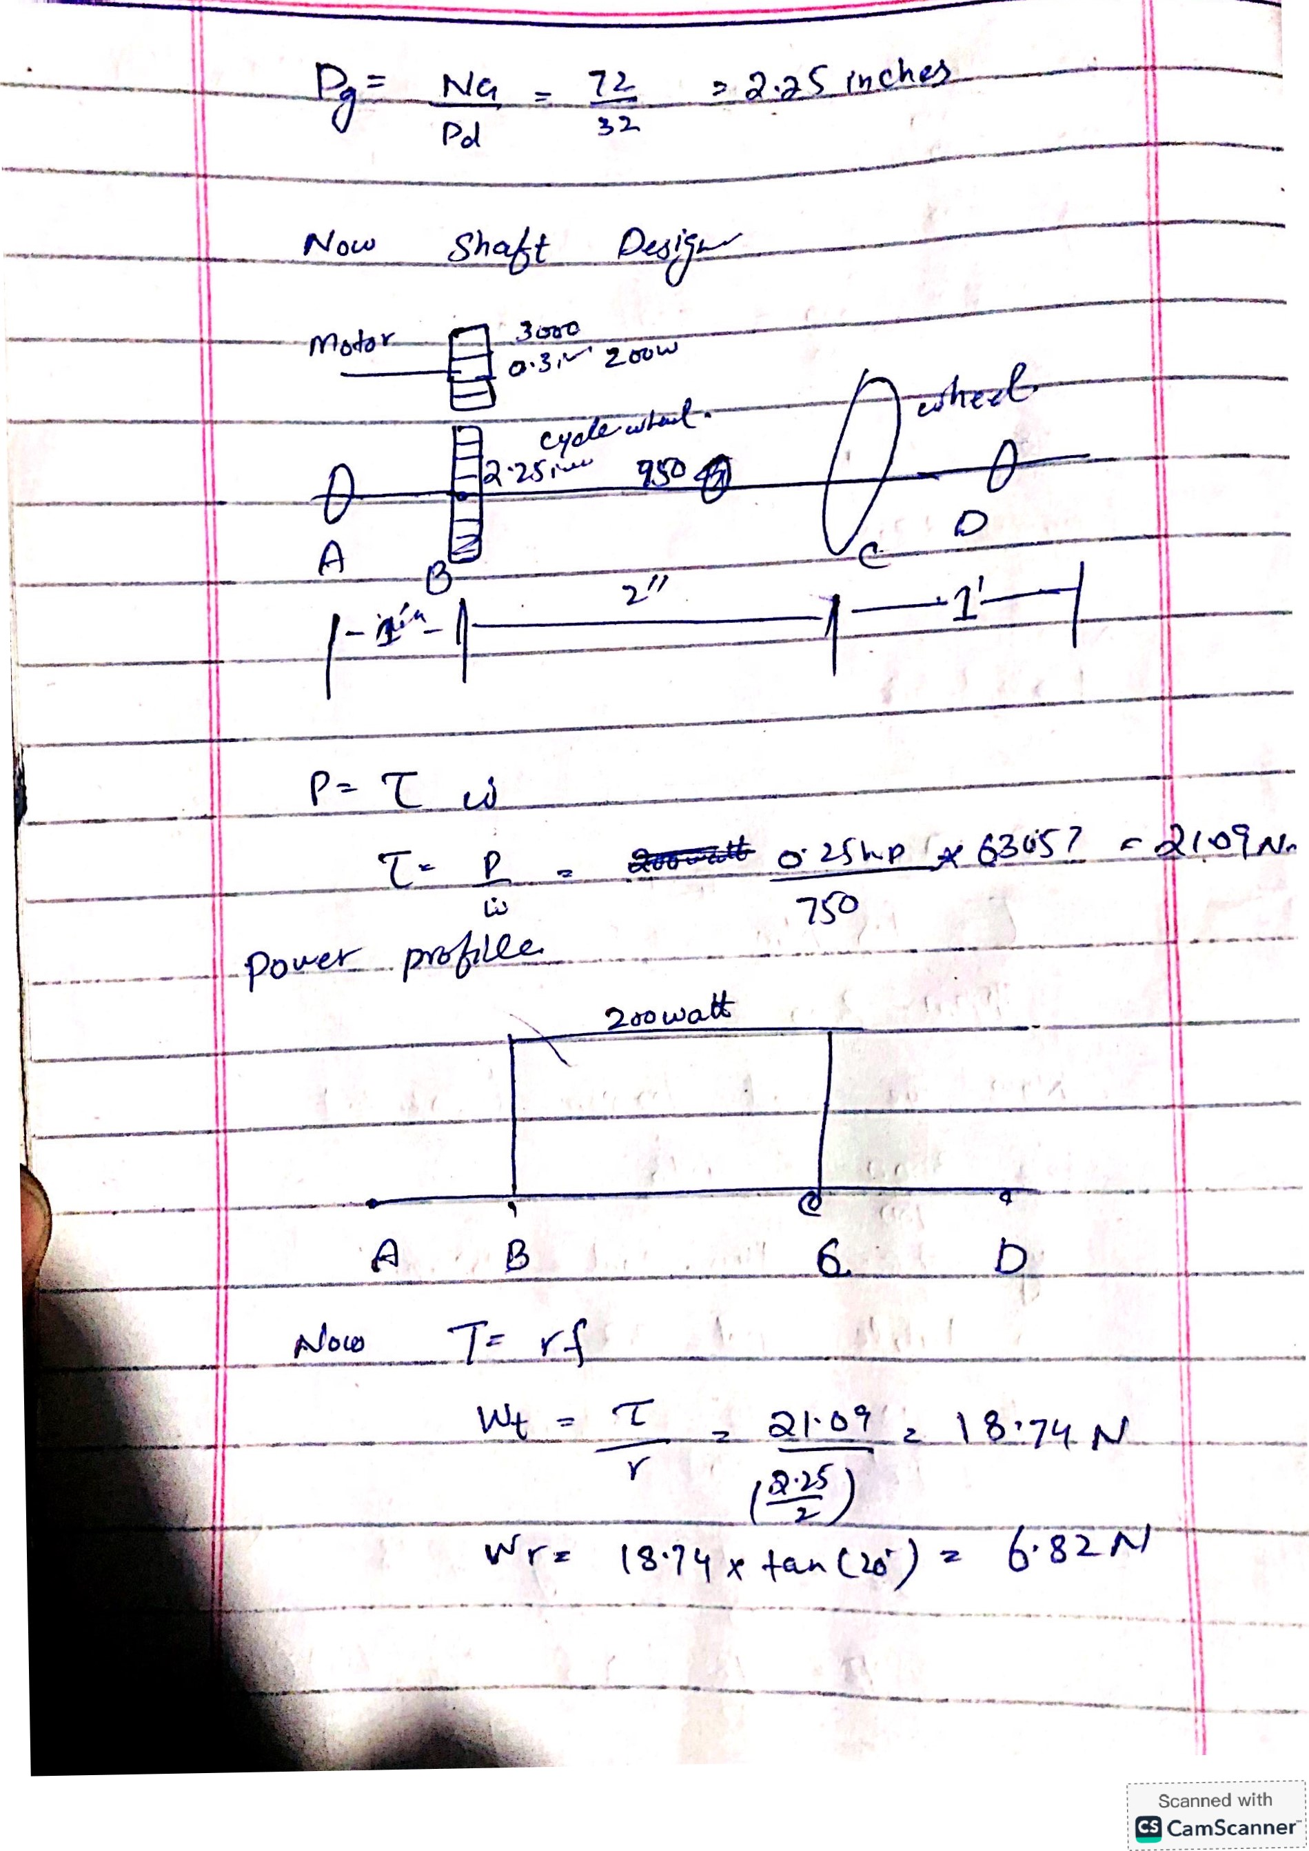

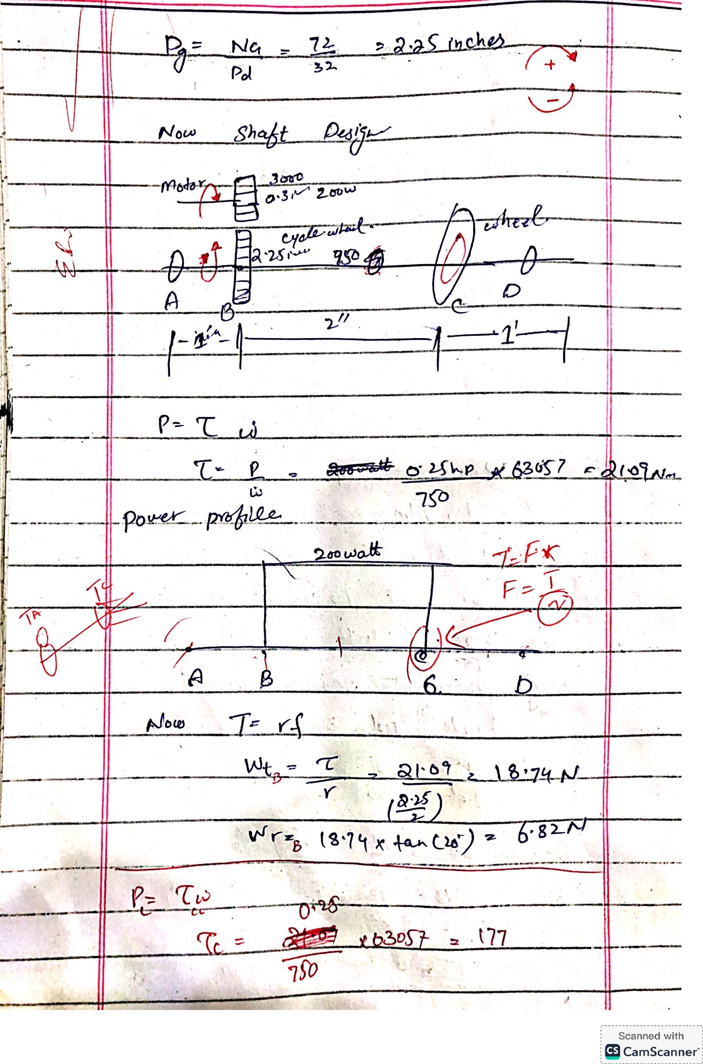

* 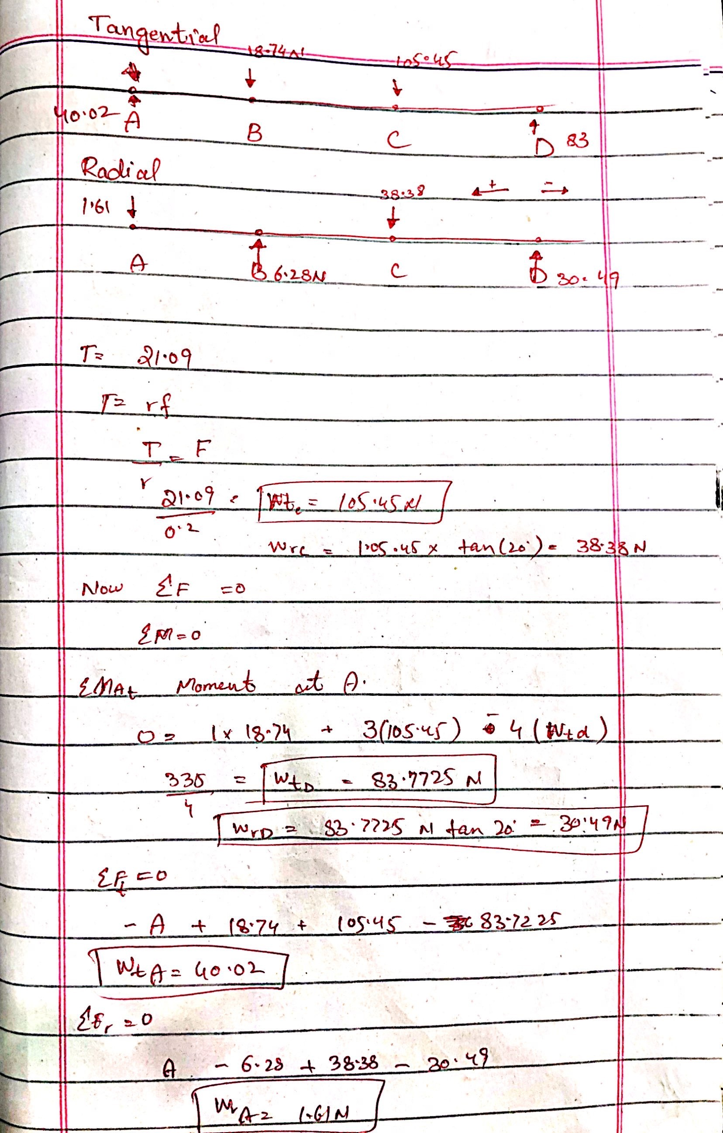
* 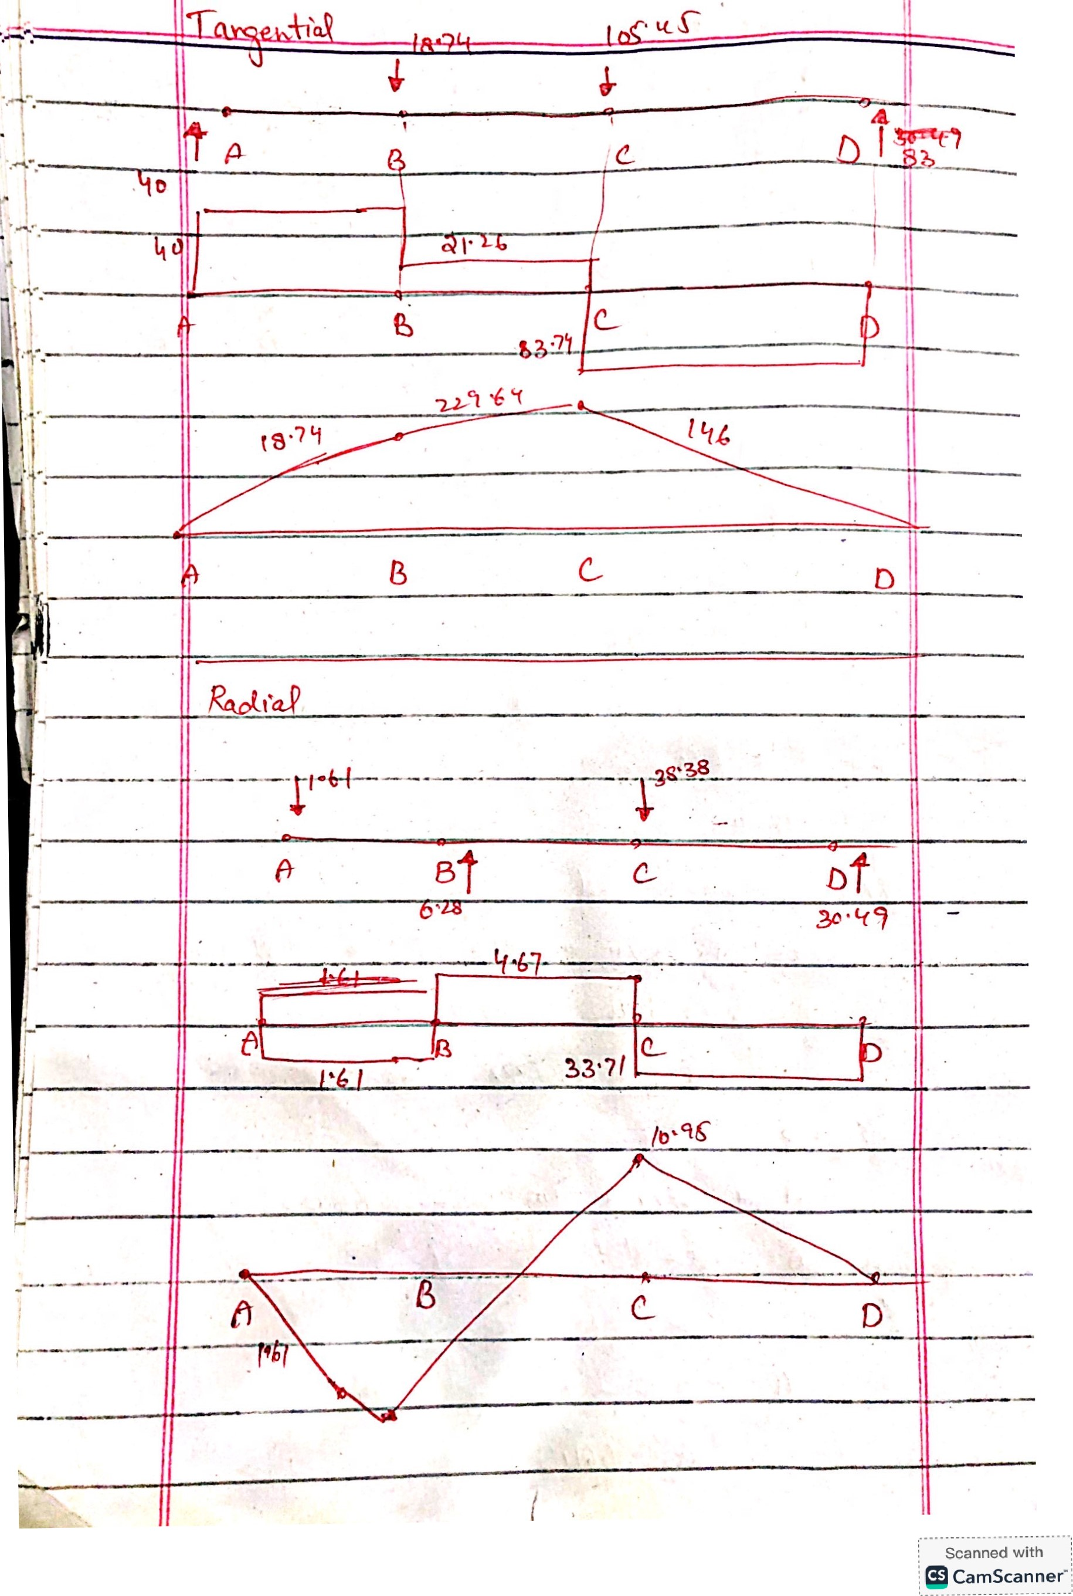
* 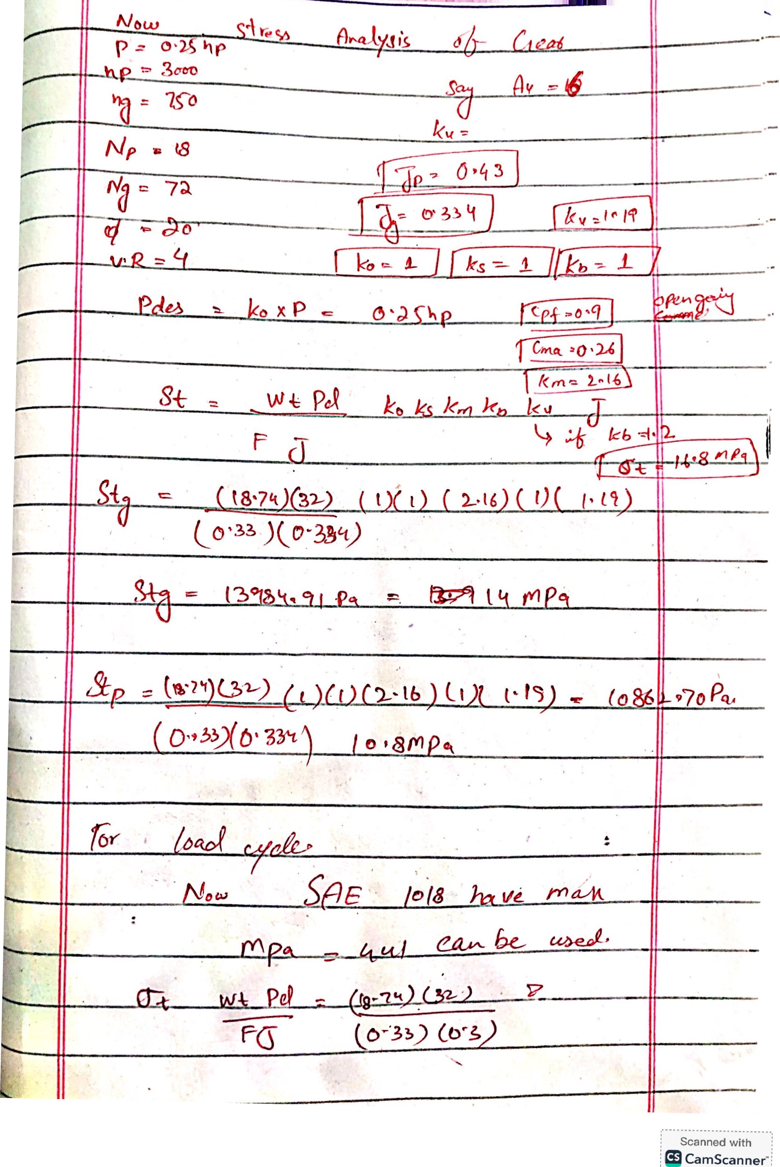d

1. Explain the reason of selection

Specify the design requirements

input speed 3000rpm Max

output speed 750 rpm

torque 0.25 Nm min

1. Describe the selected Power drive system.

I decided 0.25 HP motor BLDC

Voltage 24v,48v

Currrent 0-5 amp

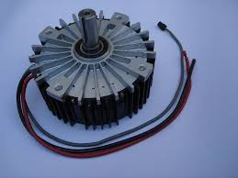

c) Describe the chosen power transmission system (belts, chains, or gear drives).

- reason of selection: Long life and High torque I choose gear system

- all the other requirements are discussed in the images of the solution

- A complete CAD model for the power transmission system.



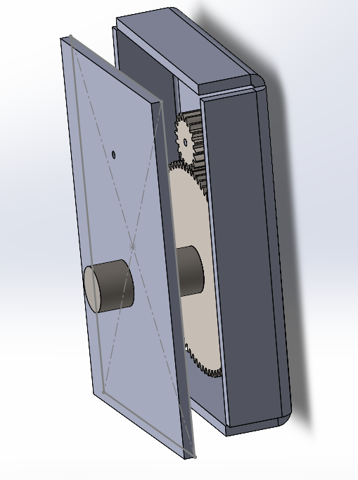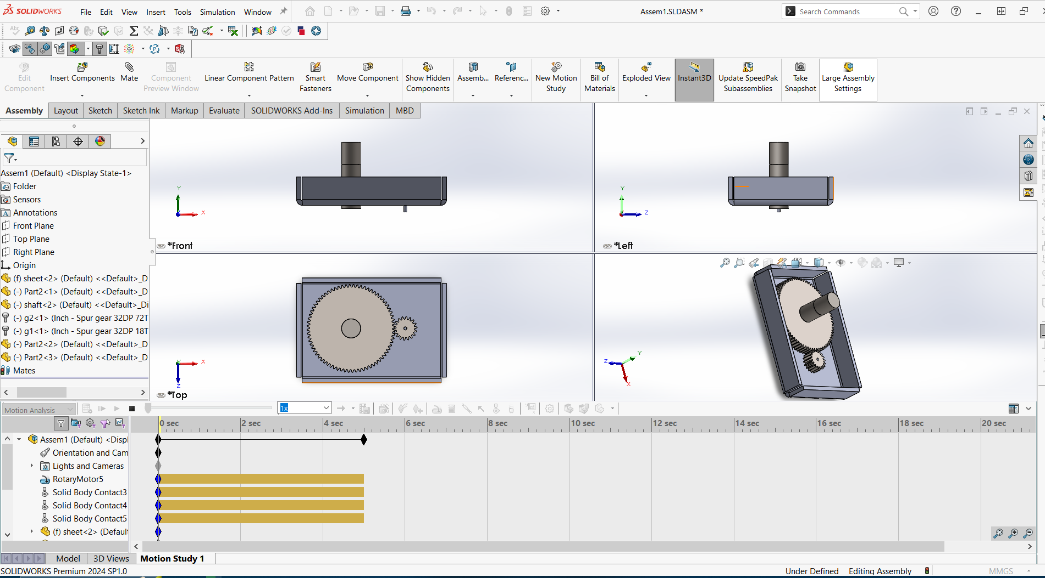

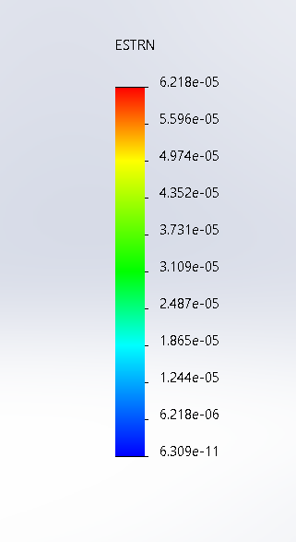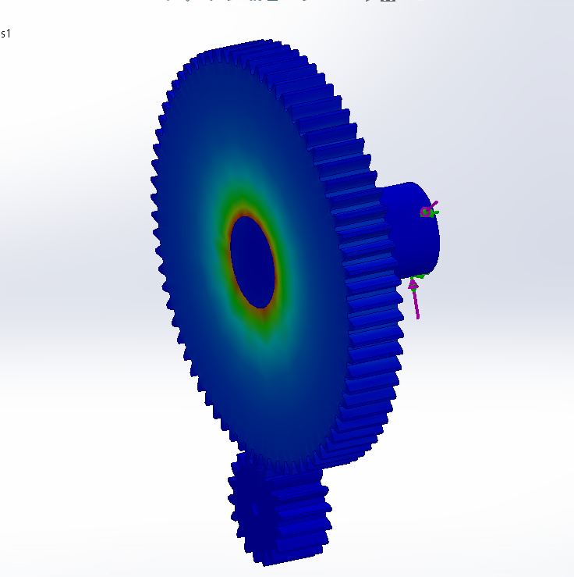

All the Calculations have been done by myself as am doing this individually

|  |  |  |  |
| --- | --- | --- | --- |
| Registration no | MathematicalDesign | Simulations | Project Report  Writing |
| 2020-MC-58 | 100% | 100% | 100% |